

Project name : DEPI HUB



Team names:
1-Mohamed Essam Mahmoud
2-Ahmed Refaat Abdelnabi
3-Faiza Ahmed Hassan Ali
4-samah Ahmed Sayed Ahmed

Table of Contents
Description: 5
Vision: 5
DEPI HUB aspires to: 5
Impact and Benefits: 6
System Analysis 7
Functional Requirements: 7
-1Profile Management: 7
-2Project Submission: 7
-3Project Verification: 7
-4Project Showcase (Portfolio Library): 7
-5Search and Filtering: 7
-6Company Access to Trainees: 8
-7Admin Dashboard: 8
-8Rating and Feedback System: 8
-9Notification System: 8
-10Communication Channel: 8
-11Analytics and Reports: 8
Non-Functional Requirements: 9
-1Performance: 9
-2Scalability: 9
-3Security: 9
-4Usability: 9
-5Availability: 9
-6Reliability: 9
-7Maintainability: 9
-8Interoperability: 9
-9 Data Integrity 10
-10 Localization: 10
Diagram 11
1-Use Case Diagram 11
2-Sequence Diagram 12
3-Activity Diagram 13
4-Flowchart 14
Final 15
Summary of the DEPI HUB : 15

Description:
DEPI HUB – A Platform that Unites Creativity, Opportunities, and the Job Market
DEPI HUB is an innovative digital platform designed to serve as a bridge between DEPI initiative trainees and the professional world.
The core idea revolves around creating a living library of projects, where trainees’ accomplishments are transformed from mere training assignments into a verified digital portfolio that showcases their practical skills and allows companies and organizations to easily discover emerging talents.

Vision:
DEPI HUB goes beyond simply displaying the outcomes of training programs. It aims to build a comprehensive ecosystem that supports trainees even after their program ends.
The platform provides a safe and trusted space for showcasing creativity and innovation while fostering healthy competition among trainees by highlighting quality and originality. This approach enhances the overall standard of submitted projects and strengthens the spirit of achievement and excellence

DEPI HUB aspires to:
- Transform trainee achievements into a lasting digital reference that demonstrates their capabilities to potential employers.
- Establish direct communication channels between young talents and companies or entrepreneurs seeking innovative ideas and solutions.
- Promote a learning-by-doing culture by highlighting the tangible impact of training through real, scalable projects

Impact and Benefits:
- Empowering Trainees:
Providing them with a trusted platform to showcase their hands-on experience and strengthen their professional presence.
- Connecting Talent with the Market:
Helping companies and recruiters discover high-potential candidates effortlessly, without intermediaries or lengthy search processes.
- Enhancing Project Quality:
Motivating trainees and teams to produce refined, high-quality work worthy of recognition and visibility.
- Documenting Achievements:
Preserving projects as a digital archive that reflects the success and legacy of DEPI, serving as a continuous source of inspiration and reference for future cohorts.

System Analysis
DEPI HUB is a digital platform that connects DEPI trainees with the job market by transforming their training projects into a verified digital portfolio. It enables companies to discover talent, promotes innovation, and supports trainees in their professional journey.

Functional Requirements:
-1Profile Management:
Trainees can create and edit their personal profiles, including basic information, skills, and educational background.
Companies can also create profiles to showcase their organization and available opportunities.

-2Project Submission:
Trainees should be able to upload their project files, including descriptions, images, technologies used, and links to live demos or GitHub repositories.

-3Project Verification:
Before being published, submitted projects will be reviewed and approved by administrators to ensure accuracy, originality, and quality.

-4Project Showcase (Portfolio Library):
The platform should display all verified projects in a public portfolio section, where visitors can browse and explore based on category or technology.

-5Search and Filtering:
Users, especially companies, should be able to search and filter projects or profiles by keywords, skills, categories, or tools used.

-6Company Access to Trainees:
Companies can view trainee profiles and projects and contact them directly for job offers or collaborations.

-7Admin Dashboard:
Administrators should have full control to manage users, approve projects, handle reports, and view overall statistics about platform activity.

-8Rating and Feedback System:
Companies or mentors can rate projects and provide constructive feedback to help trainees improve their work.

-9Notification System:
The system should send notifications to users regarding project approvals, received feedback, and messages.

-10Communication Channel:
A secure messaging system should be available to allow direct communication between trainees and companies while maintaining privacy.

-11Analytics and Reports:
The system should generate statistical reports for administrators, showing data such as the number of active users, projects, and most-viewed profiles.

Non-Functional Requirements:

-1Performance:
The platform should perform efficiently, ensuring that page’s load quickly (ideally within 3 seconds under normal conditions).

-2Scalability:
The system should be designed to handle a growing number of users and projects without performance degradation.

-3Security:
All user data and credentials must be protected using secure authentication methods (e.g., HTTPS, JWT, password encryption).

-4Usability:
The user interface should be intuitive, simple, and visually appealing, making navigation easy for all user types.
It must also be responsive to work smoothly on desktops, tablets, and mobile devices.

-5Availability:
The platform should maintain a high uptime rate (around 99%), ensuring users can access it almost anytime.

-6Reliability:
Data must be stored safely with regular backups to prevent loss or corruption of user and project information.

-7Maintainability:
The codebase should follow clean architecture principles and modular design to make future updates, fixes, or feature additions easier.

-8Interoperability:
The platform should be capable of integrating with external services such as LinkedIn, GitHub, or email APIs for enhanced functionality.

-9 Data Integrity
The system must ensure that all uploaded data remains consistent, accurate, and protected from unauthorized modifications.

-10 Localization:
DEPI HUB should support both Arabic and English interfaces to reach a wider audience and improve accessibility.

Diagram
1-Use Case Diagram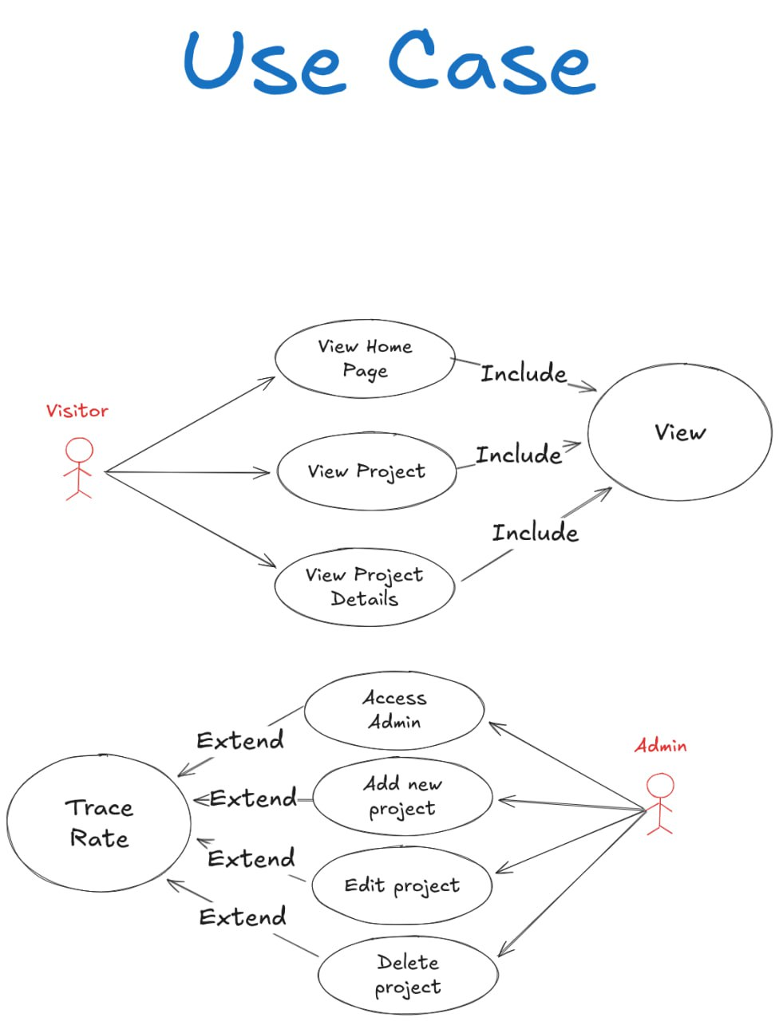
2-Sequence Diagram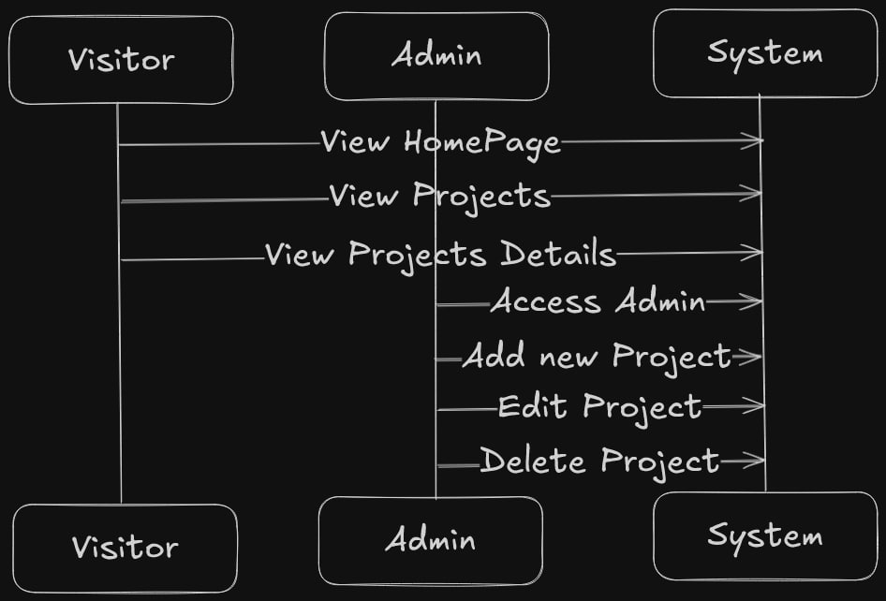

3-Activity Diagram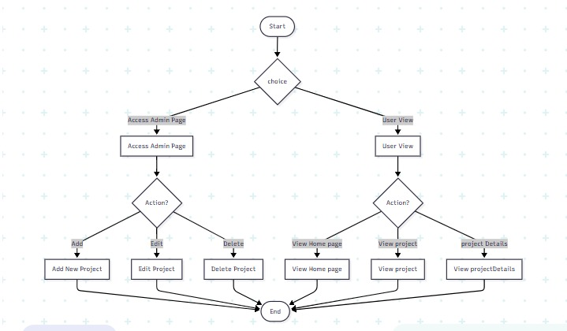

4-Flowchart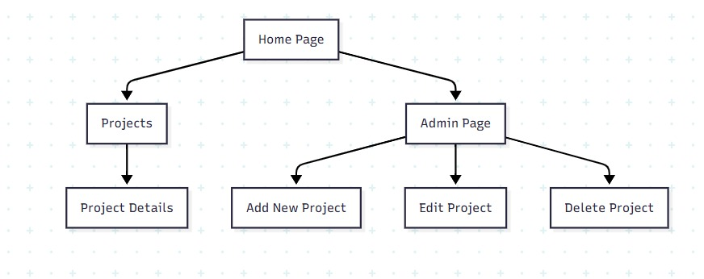

Final

Summary of the DEPI HUB:
DEPI HUB is an innovative digital bridge designed to transform the post-training journey for graduates. It moves beyond simply certifying completion, by converting trainees' project work into verified, trusted digital portfolios that provide companies with tangible proof of practical skills and execution capability.
The core concept revolves around creating a living project library, where work transitions from being closed training assignments to open, discoverable achievements. This vision is realized through an integrated system: a trainee submits their project (including descriptions, technologies, and links), it undergoes an administrative review and approval process to ensure quality and authenticity and is then published in a public gallery that is browsable and searchable via filters (by technology, skill, category).
The platform features three main gateways: a Trainee Portal for profile creation, project display, and receiving feedback/messages; a Company Portal for talent discovery and direct communication; and a comprehensive Admin Portal for overseeing all operations and platform analytics.
DEPI HUB transcends the idea of a simple online showcase to build a complete support ecosystem. It fosters a "learning-by-doing" culture and stimulates healthy competition by highlighting exceptional work. To this end, it provides secure communication channels between parties, a rating and feedback system, and a seamless, responsive design that works across all devices and supports both Arabic and English interfaces to ensure broad accessibility.
The ultimate outcome is a triple-benefit impact: empowering the trainee by placing them directly in the spotlight of the job market, simplifying the company's task of finding proven talent, and enhancing the value and quality of the training program's output itself, transforming it into a digital legacy that preserves success and inspires future cohorts. In essence, DEPI HUB is a practical bridge that turns ideas into opportunities and projects into careers.

